**UID EXERCISE 4**

**FAMILIAR AND UNFAMILIAR NAVIGATION**

This exercise is about the user navigation to different parts of the application.

There are two types:

1. Familiar Navigation
2. Unfamiliar Navigation

Familiar Navigation

This is when the user knows where he will be led to upon touching the icon, link etc.

It mostly is based on the muscle memory as the user must have had a previous experience on that particular basis and knows where he will be led to.

Example: **eBay (ebay.com):**

Unfamiliar Navigation

This is when the user is not sure or doesn’t know where he will be lead to, meaning he doesn’t know until he clicks or touches it. Then only the user will know that clicking it will lead to this page or whatsoever.

This can be of the type unknown icon, gesture-based etc.

Example: **Awwwards (awwwards.com):**

This project is done in Proto.io website to showcase the familiar and unfamiliar navigations.

Familiar navigation page:

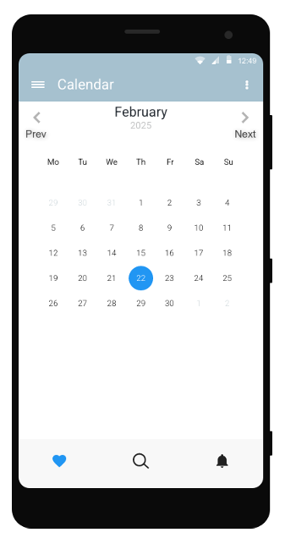

Here the ‘heart (like)’, ‘Magnifying glass (search)’ and ‘bell (notification)’. These icons are known to the user before-hand as it is pretty common in most of the applications.

The bell icon alone is a clickable button that leads to the next page.

Hence the user will know what that particular icon will do upon touching them.

Unfamiliar navigation page:

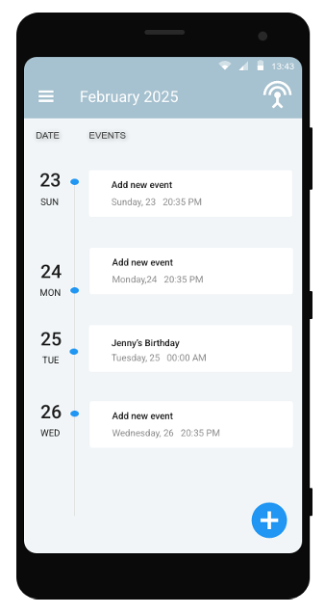

Here the top right icon is pretty much new and the user doesn’t know what it will do unless and until he touches it. This resembles unfamiliar navigation.

When that icon is clicked:

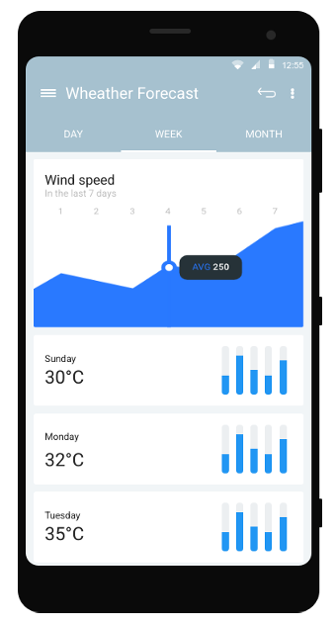

As we can see, when that unfamiliar icon is clicked it leads us to the weather forecast page from the calendar page.

Link to this project in proto.io : [Exercise 4 in proto.io](https://pr.to/9T026R/)